(E5.4) A feedback system with negative unity feedback has a loop transfer function

1. Determine the closed-loop transfer function T(s) = Y(s)/R(s).
2. Find the time response, y(t), for a step input r(t) = A for t > 0.
3. Using Figure 5.13(a), determine the overshoot of the response.
4. Using the final-value theorem, determine the steady-state value of y(t).

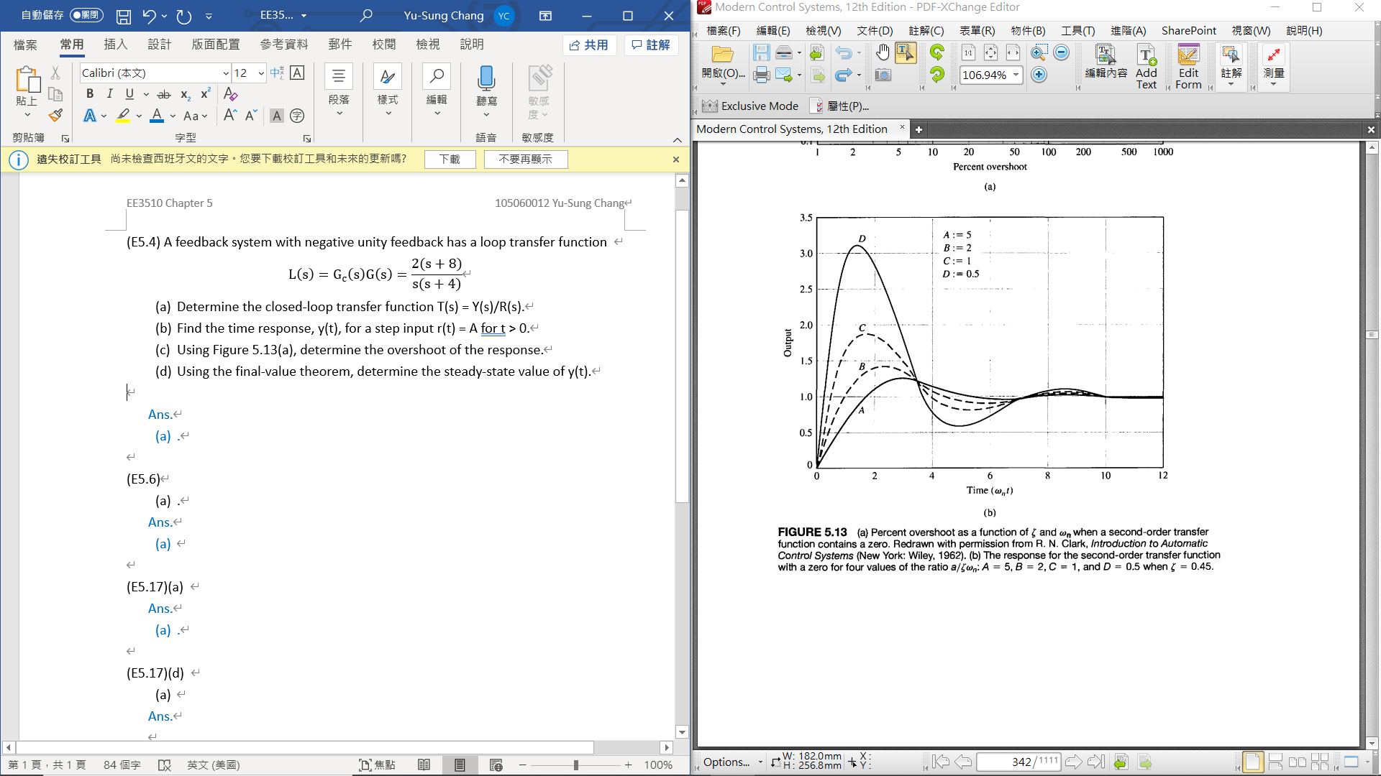

Ans.

1. .

Step input ,

1. 🡪 and .

1. This is a type 1 system, thus the steady-state error is zero and y(t) →A as t →∞.

(E5.6) Consider the block diagram shown in Figure E5.6.

1. Calculate the steady-state error for a ramp input.
2. Select a value of K that will result in zero overshoot to a step input. Provide the most rapid response that is attainable.

Plot the poles and zeros of this system and discuss the dominance of the complex poles. What overshoot for a step input do you expect?

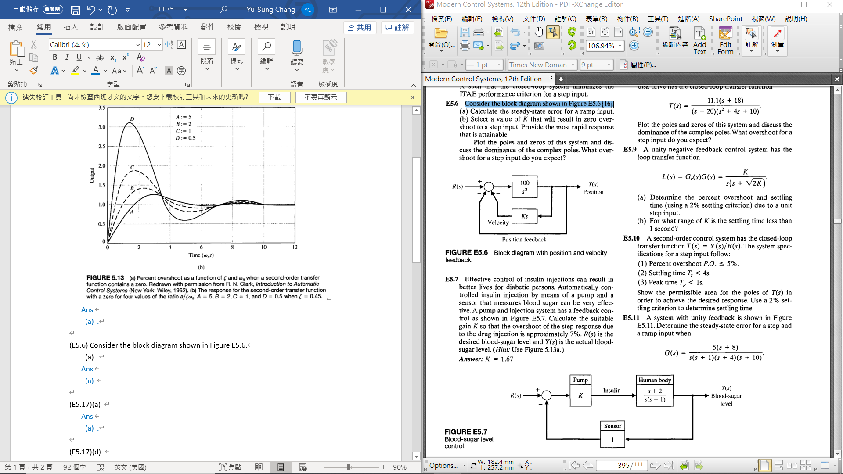

Ans.

1. Ramp input , , where and

* The steady-state error is

1. Natural frequency , damping ratio

ps. Overdamped , Underdamped , critically damping

critically damping

(E5.17)(a) A closed-loop control system transfer function T(s) has two dominant complex conjugate poles. Sketch the region in the left-hand 5-plane where the complex poles should be located to meet the given specifications.

.

Ans.

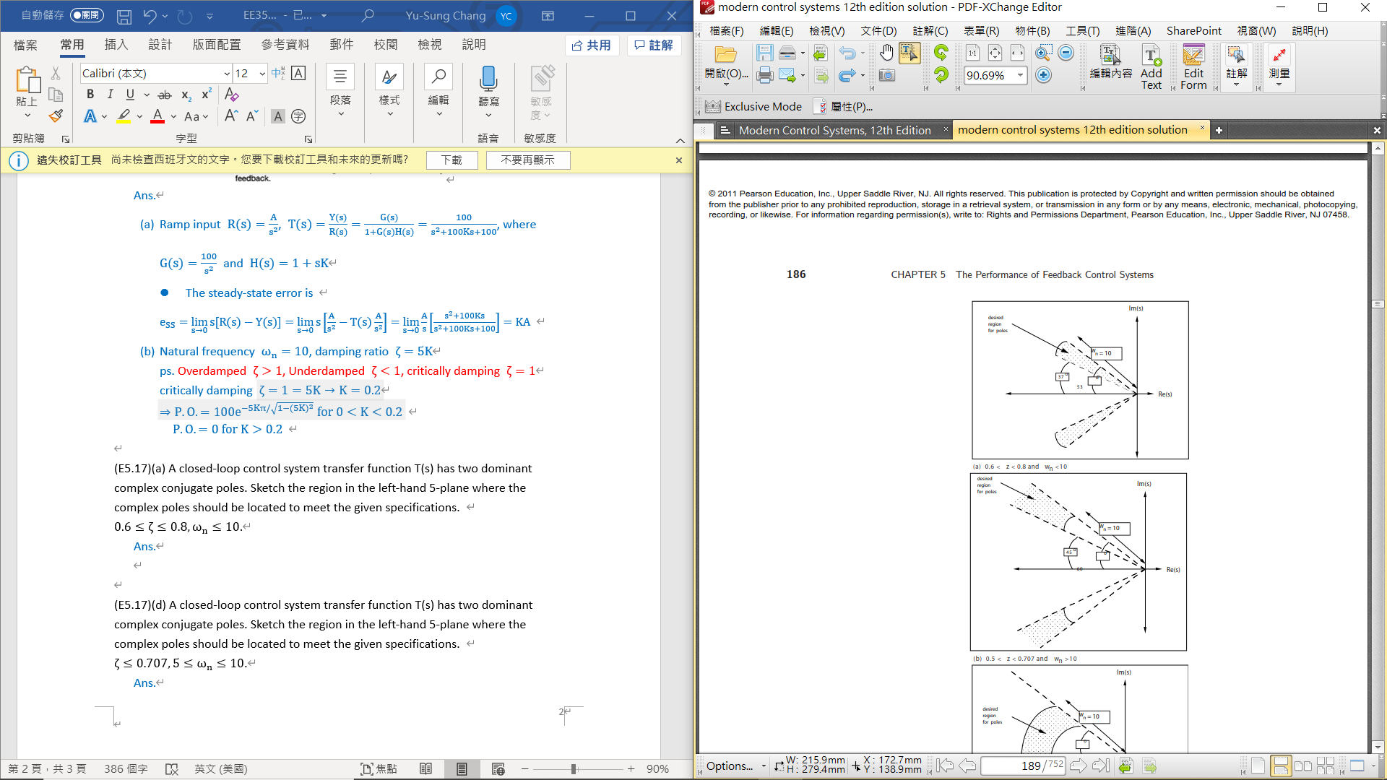

(E5.17)(d) A closed-loop control system transfer function T(s) has two dominant complex conjugate poles. Sketch the region in the left-hand 5-plane where the complex poles should be located to meet the given specifications.

.

Ans.

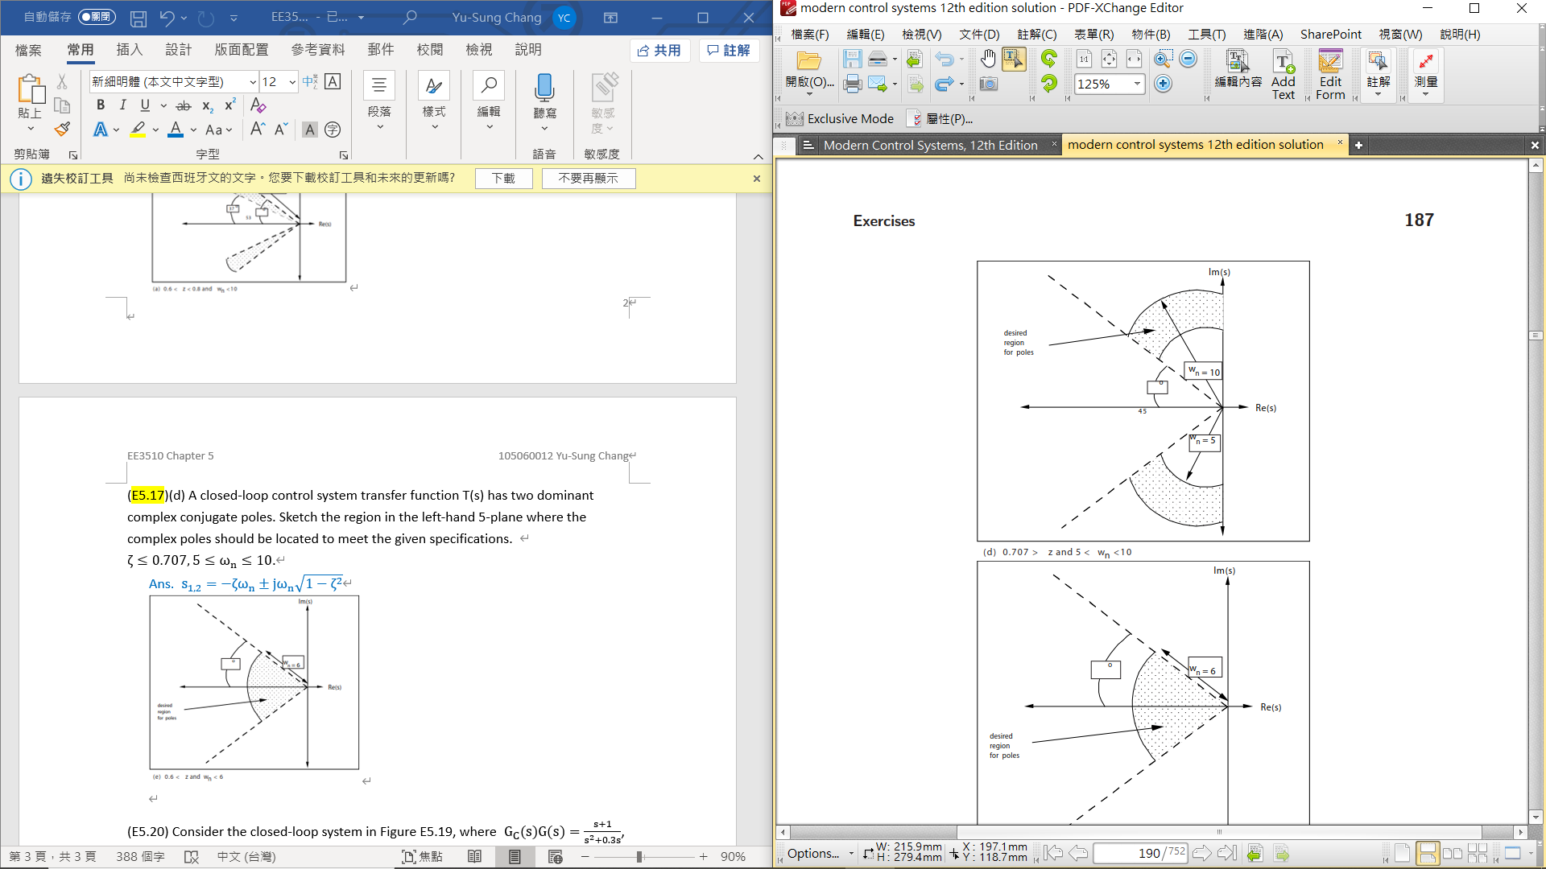

(E5.20) Consider the closed-loop system in Figure E5.19, where , and .

1. Determine the closed-loop transfer function T(s) = Y(s)/R(s).
2. Determine the steady-state error of the closed-loop system response to a unit ramp input, .
3. Select a value for Ka so that the steady-state error of the system response to a unit step input, R(s) = 1/s, is zero.

Ans.



(P5.20) A system is shown in Figure P5.20.

1. Determine the steady-state error for a unit step input in terms of K and K1, where E(s) = R(s) - Y(s).
2. Select K1 so that the steady-state error is zero.

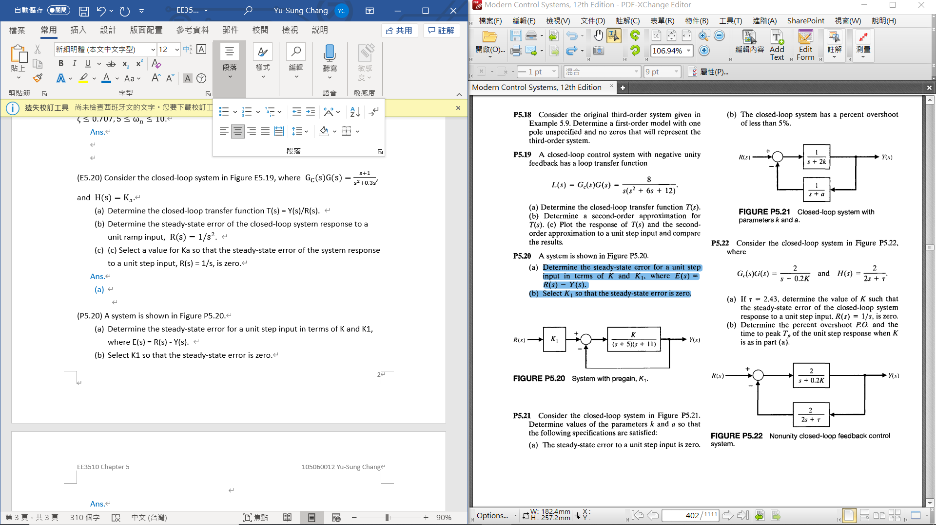

Ans.

1. To achieve zero steady-state error,

\*\*\*\*\* Important Equation in Chapter 5 \*\*\*\*\*

1. Second Order System
   1. Overshoot
   2. Peak time
   3. Settling time
   4. Poles
2. Standard Test Input Signals
   1. Step Signals:
   2. Ramp Signals:
   3. Parabolic Signals: